**Employee Management System**

**User Manual**

**CPSC-488 Spring 2023**

**02/26/2023**

**Maya Smallwood** [mns1013@sru.edu](mailto:mns1013@sru.edu)

**Paul Schlabach** [pms1006@sru.edu](mailto:pms1006@sru.edu)

**Bradon Walters** [bdw1006@sru.edu](mailto:bndw1006@sru.edu)

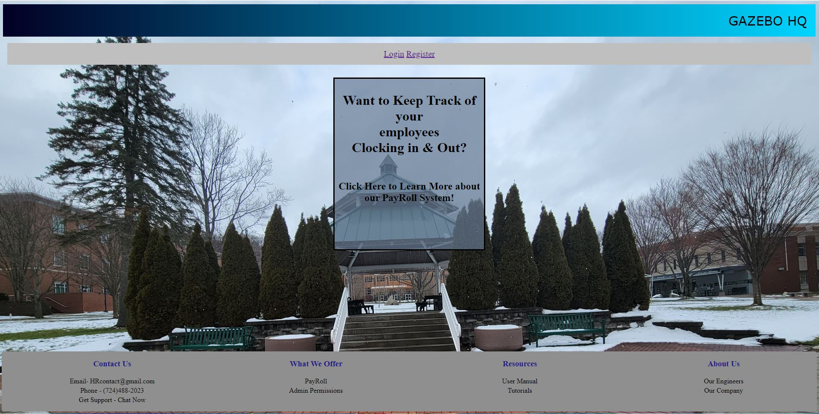

Figure 1. Landing Page

* Upon reaching the application, user’s will see this landing page
* They will have the option to Login or register a new account

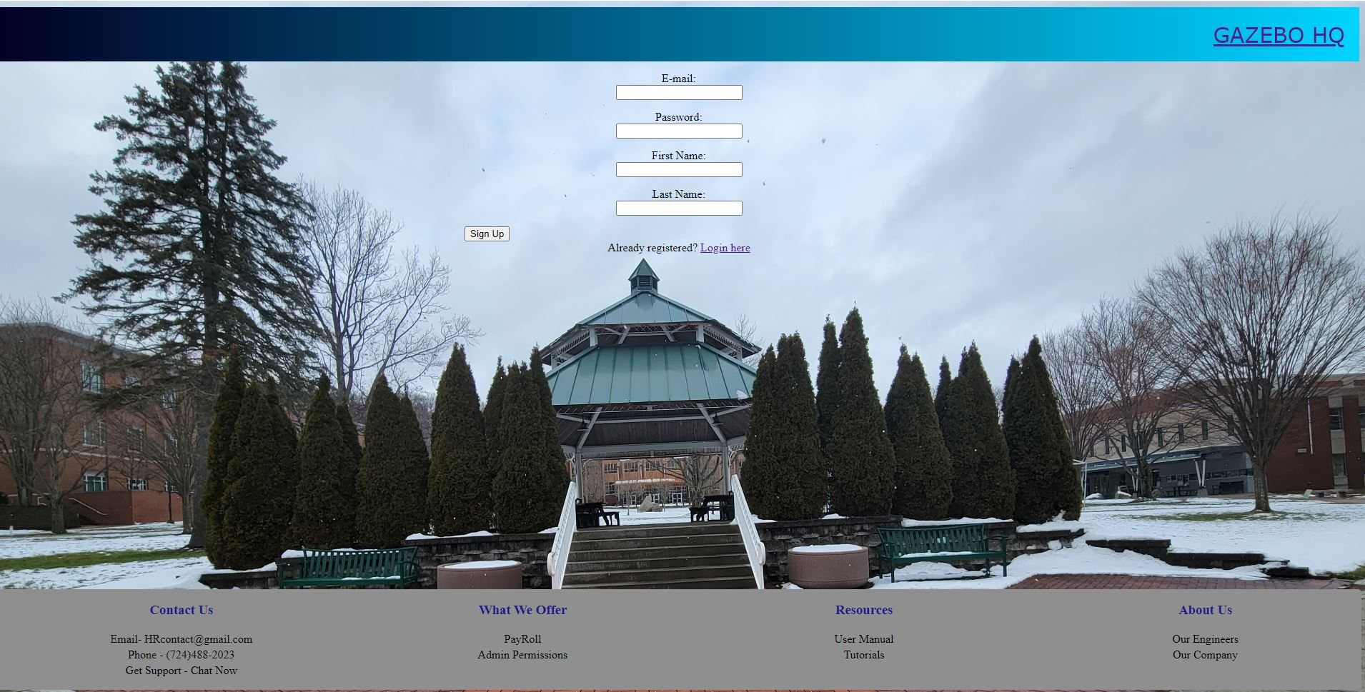

Figure 2. Registration Page

* Upon reaching the registration page the user will be prompted to enter an email, password, first, and last name
* Once entered the user will select the “sign up” button or if they mistakenly clicked registration they may click “Login here” if they already have an account

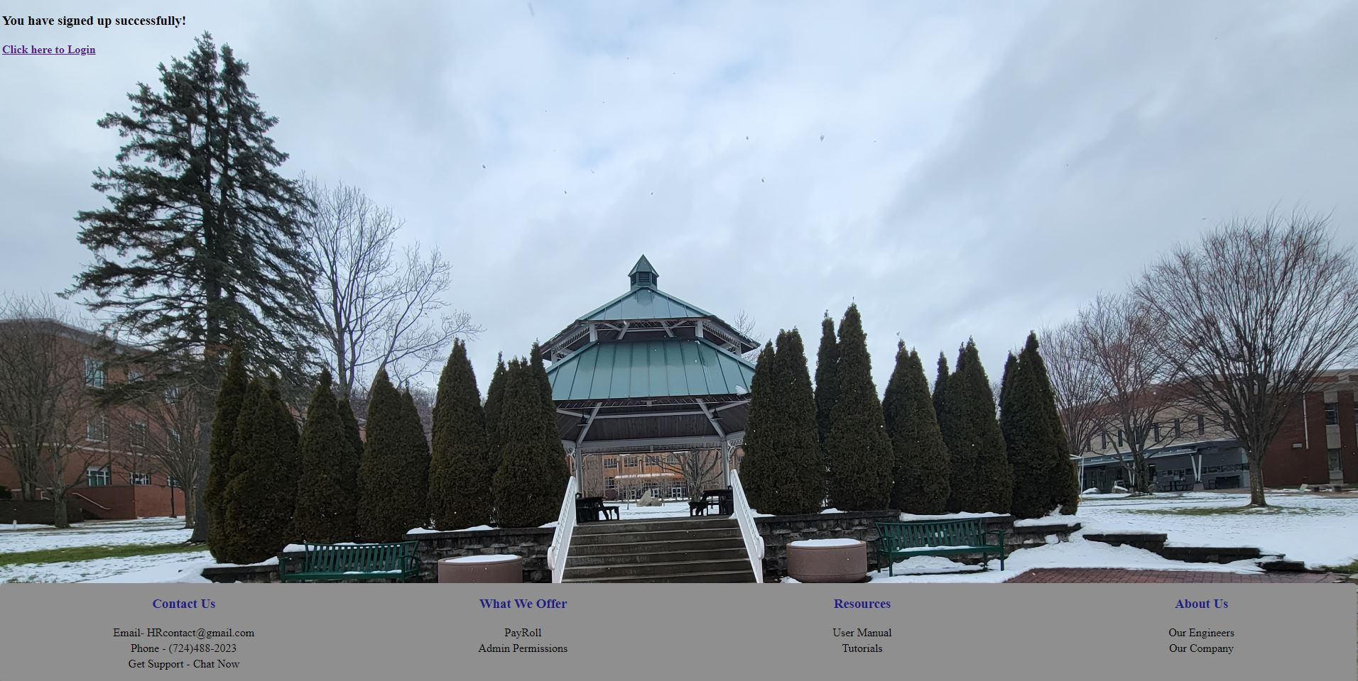

Figure 3. Registration Succesful Page

* Once clicking “sign up” users will reach a screen prompting them to login the the system

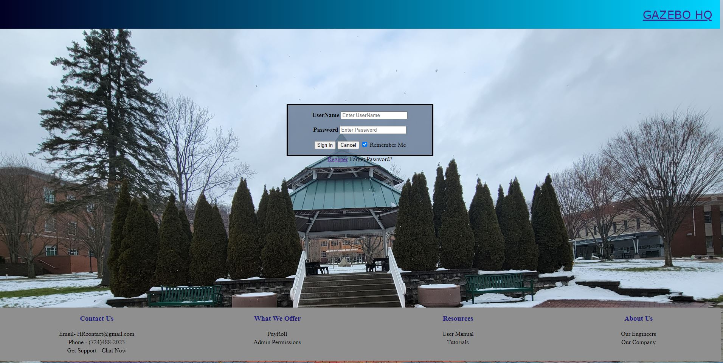

Figure 4. Login Page

* Once on the login page users will sign in using their email and password associated with the account they registered

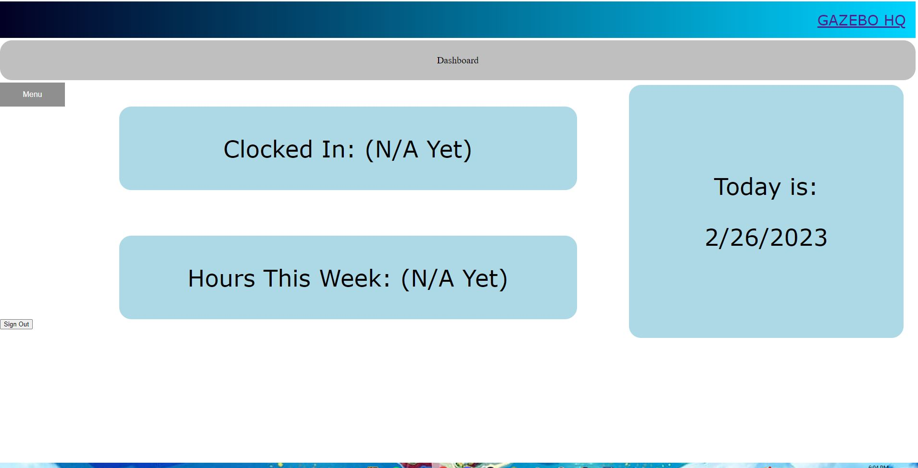

Figure 5. Application Dashboard

* Once logged in, users will be sent to the dashboard. On this page users can see what today’s date is, if they are clocked in currently and how many hours they have worked this pay period
* If users hover their mouse over the menu button. A dropdown menu will appear showing users their different options within the application

(Note to Dr. Sam, as of right now the login page will still not send users to the dashboard we are working to fix this, we believe it is due to security configs within the login code)